AUTOMATIC CLASSIFICATION OF KNEE OSTEOARTHRITIS SEVERITY USING GAIT DATA AND RADIO GRAPHIC IMAGES.

ABSTRACT:
KNEE Bone disease detection is a critical task in the field of medical diagnostics, as early and accurate identification of malignant bone tumors can significantly improve patient outcomes. Deep learning, a subset of artificial intelligence, has emerged as a powerful tool for automating the detection of KNEE Bone disease from medical images, such as X-rays, CT scans, and MRIs. This abstract provides an overview of the key aspects involved in developing a KNEE Bone disease detection system using deep learning techniques.The process begins with the collection of a comprehensive dataset of medical images, meticulously curated to include both disease and normal cases. These images are preprocessed to ensure uniformity in size and format and are divided into training, validation, and test sets. A suitable deep learning architecture, often a Convolutional Neural Network (CNN-resnet), is chosen or customized to learn intricate patterns within the images.
INTRODUCTION:
Knee bone detection using Convolutional Neural Networks (CNNs) represents an innovative and vital area in medical imaging and computer vision. The knee joint is a complex structure comprising bones, cartilage, ligaments, and other tissues. Accurate detection and segmentation of knee bones are essential for diagnosing various musculoskeletal disorders, planning surgeries, and monitoring treatment responses.Convolutional Neural Networks (CNNs) have gained prominence in medical image analysis due to their ability to learn intricate patterns and features from image data. By leveraging CNNs, researchers and medical professionals can automate the process of identifying, localizing, and segmenting knee bones in medical images such as X-rays, MRIs, or CT scans. This technology significantly aids in streamlining the diagnostic process and enhancing the accuracy of medical assessments.
DIGITAL IMAGE PROCESSING

The identification of objects in an image and this process would probably start with image processing techniques such as noise removal, followed by (low-level) feature extraction to locate lines, regions and possibly areas with certain textures.
The clever bit is to interpret collections of these shapes as single objects, e.g. cars on a road, boxes on a conveyor belt or cancerous cells on a microscope slide. One reason this is an AI problem is that an object can appear very different when viewed from different angles or under different lighting. Another problem is deciding what features belong to what object and which are background or shadows etc. The human visual system performs these tasks mostly unconsciously but a computer requires skilful programming and lots of processing power to approach human performance. Manipulation of data in the form of an image through several possible techniques. An image is usually interpreted as a two-dimensional array of brightness values, and is most familiarly represented by such patterns as those of a photographic print, slide, television screen, or movie screen. An image can be processed optically or digitally with a computer.

- Basics of Image Processing:-

FUNDAMENTALS OF DIGITAL IMAGE

1.1 IMAGE:
An image is a two-dimensional picture, which has a similar appearance to some subject usually a physical object or a person.

Image is a two-dimensional, such as a photograph, screen display, and as well as a three-dimensional, such as a statue. They may be captured by optical devices—such as cameras, mirrors, lenses, telescopes, microscopes, etc. and natural objects and phenomena, such as the human eye or water surfaces.

The word image is also used in the broader sense of any two-dimensional figure such as a map, a graph, a pie chart, or an abstract painting. In this wider sense, images can also be rendered manually, such as by drawing, painting, carving, rendered automatically by printing or computer graphics technology, or developed by a combination of methods, especially in a pseudo-photograph.


Fig: Colour image to Gray scale Conversion Process
An image is a rectangular grid of pixels. It has a definite height and a definite width counted in pixels. Each pixel is square and has a fixed size on a given display. However different computer monitors may use different sized pixels. The pixels that constitute an image are ordered as a grid (columns and rows); each pixel consists of numbers representing magnitudes of brightness and color.
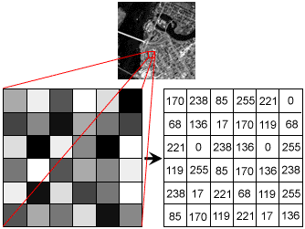
Fig: Gray Scale Image Pixel Value Analysis
Each pixel has a color. The color is a 32-bit integer. The first eight bits determine the redness of the pixel, the next eight bits the greenness, the next eight bits the blueness, and the remaining eight bits the transparency of the pixel.
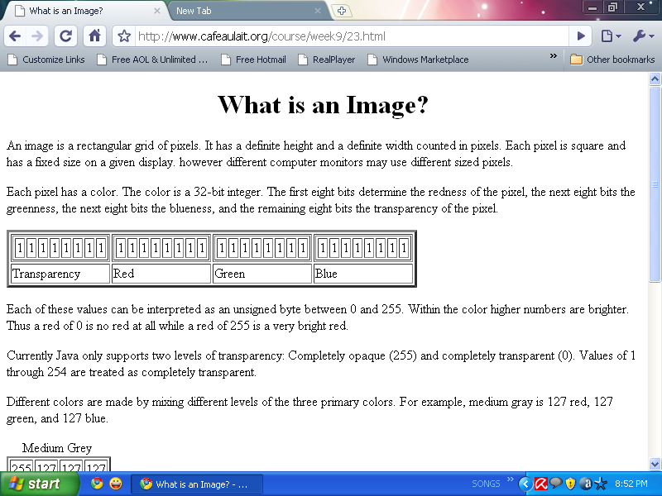
Fig: BIT Transferred for Red, Green and Blue plane (24bit=8bit red;8-bit green;8bit blue)
IMAGE FILE SIZES:
Image file size is expressed as the number of bytes that increases with the number of pixels composing an image, and the color depth of the pixels. The greater the number of rows and columns, the greater the image resolution, and the larger the file. Also, each pixel of an image increases in size when its color depth increases, an 8-bit pixel (1 byte) stores 256 colors, a 24-bit pixel (3 bytes) stores 16 million colors, the latter known as true color.Image compression uses algorithms to decrease the size of a file. High resolution cameras produce large image files, ranging from hundreds of kilobytes to megabytes, per the camera's resolution and the image-storage format capacity. High resolution digital cameras record 12 megapixel (1MP = 1,000,000 pixels / 1 million) images, or more, in true color. For example, an image recorded by a 12 MP camera; since each pixel uses 3 bytes to record true color, the uncompressed image would occupy 36,000,000 bytes of memory, a great amount of digital storage for one image, given that cameras must record and store many images to be practical. Faced with large file sizes, both within the camera and a storage disc, image file formats were developed to store such large images.
IMAGE FILE FORMATS:
Image file formats are standardized means of organizing and storing images. This entry is about digital image formats used to store photographic and other images. Image files are composed of either pixel or vector (geometric) data that are rasterized to pixels when displayed (with few exceptions) in a vector graphic display. Including proprietary types, there are hundreds of image file types. The PNG, JPEG, and GIF formats are most often used to display images on the Internet.
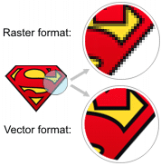
Fig: Horizontal and Vertical Process
In addition to straight image formats, Metafile formats are portable formats which can include both raster and vector information. The metafile format is an intermediate format. Most Windows applications open metafiles and then save them in their own native format.
IMAGE PROCESSING:
Digital image processing, the manipulation of images by computer, is relatively recent development in terms of man’s ancient fascination with visual stimuli. In its short history, it has been applied to practically every type of images with varying degree of success. The inherent subjective appeal of pictorial displays attracts perhaps a disproportionate amount of attention from the scientists and also from the layman. Digital image processing like other glamour fields, suffers from myths, mis-connect ions, mis-understandings and mis-information. It is vast umbrella under which fall diverse aspect of optics, electronics, mathematics, photography graphics and computer technology. It is truly multidisciplinary endeavor ploughed with imprecise jargon.
Several factor combine to indicate a lively future for digital image processing. A major factor is the declining cost of computer equipment. Several new technological trends promise to further promote digital image processing. These include parallel processing mode practical by low cost microprocessors, and the use of charge coupled devices (CCDs) for digitizing, storage during processing and display and large low cost of image storage arrays.
FUNDAMENTAL STEPS IN DIGITAL IMAGE PROCESSING:
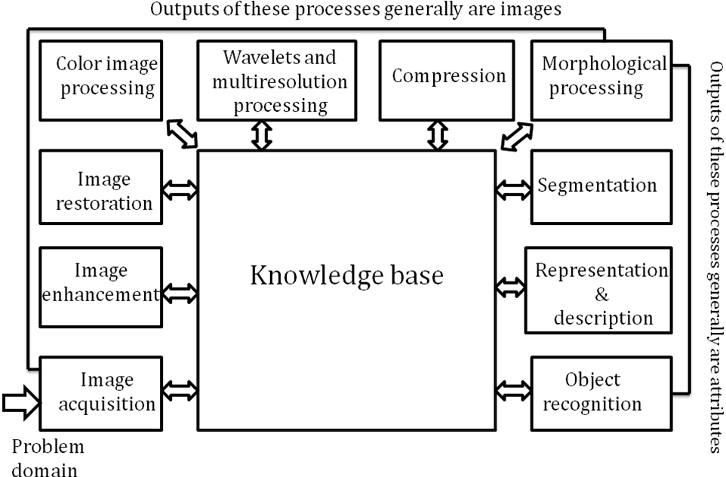Fig: Basics steps of image Processing

Image Acquisition:
Image Acquisition is to acquire a digital image. To do so requires an image sensor and the capability to digitize the signal produced by the sensor. The sensor could be monochrome or color TV camera that produces an entire image of the problem domain every 1/30 sec. the image sensor could also be line scan camera that produces a single image line at a time. In this case, the objects motion past the line.
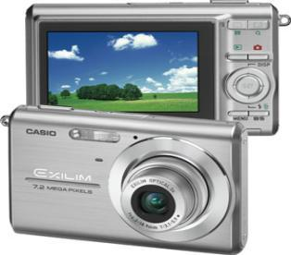
Fig: Digital camera
Scanner produces a two-dimensional image. If the output of the camera or other imaging sensor is not in digital form, an analog to digital converter digitizes it. The nature of the sensor and the image it produces are determined by the application.
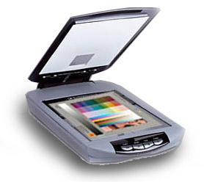
Fig: Mobile based Camera
Image Enhancement:

Image enhancement is among the simplest and most appealing areas of digital image processing. Basically, the idea behind enhancement techniques is to bring out detail that is obscured, or simply to highlight certain features of interesting an image. A familiar example of enhancement is when we increase the contrast of an image because “it looks better.” It is important to keep in mind that enhancement is a very subjective area of image processing.


Fig: Image enhancement process for Gray Scale Image and Colour Image using Histogram Bits

1.5.3 Image restoration:

Image restoration is an area that also deals with improving the appearance of an image. However, unlike enhancement, which is subjective, image restoration is objective, in the sense that restoration techniques tend to be based on mathematical or probabilistic models of image degradation.

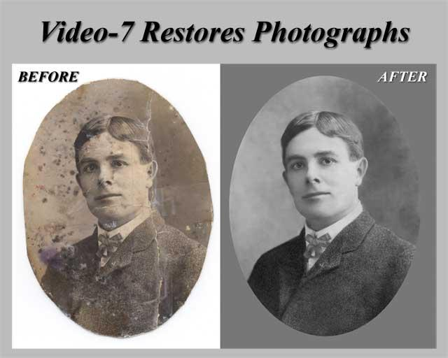
Fig: Noise image🡪 Image Enhancement

Enhancement, on the other hand, is based on human subjective preferences regarding what constitutes a “good” enhancement result. For example, contrast stretching is considered an enhancement technique because it is based primarily on the pleasing aspects it might present to the viewer, where as removal of image blur by applying a deblurring function is considered a restoration technique.

Color image processing:

The use of color in image processing is motivated by two principal factors. First, color is a powerful descriptor that often simplifies object identification and extraction from a scene. Second, humans can discern thousands of color shades and intensities, compared to about only two dozen shades of gray. This second factor is particularly important in manual image analysis.

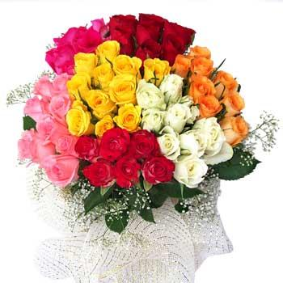
Fig: gray Scale image 🡪 Colour Image

Segmentation:

Segmentation procedures partition an image into its constituent parts or objects. In general, autonomous segmentation is one of the most difficult tasks in digital image processing. A rugged segmentation procedure brings the process a long way toward successful solution of imaging problems that require objects to be identified individually.

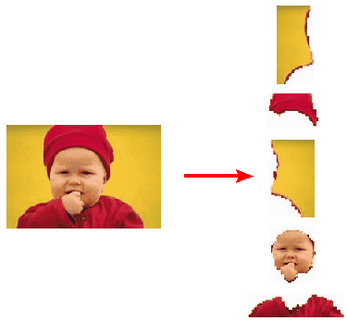
Fig: Image Segment Process

On the other hand, weak or erratic segmentation algorithms almost always guarantee eventual failure. In general, the more accurate the segmentation, the more likely recognition is to succeed.
Digital image is defined as a two dimensional function f(x, y), where x and y are spatial (plane) coordinates, and the amplitude of f at any pair of coordinates (x, y) is called intensity or grey level of the image at that point. The field of digital image processing refers to processing digital images by means of a digital computer. The digital image is composed of a finite number of elements, each of which has a particular location and value. The elements are referred to as picture elements, image elements, pels, and pixels. Pixel is the term most widely used.
Image Compression

Digital Image compression addresses the problem of reducing the amount of data required to represent a digital image. The underlying basis of the reduction process is removal of redundant data. From the mathematical viewpoint, this amounts to transforming a 2D pixel array into a statically uncorrelated data set. The data redundancy is not an abstract concept but a mathematically quantifiable entity. If n1 and n2 denote the number of information-carrying units in two data sets that represent the same information, the relative data redundancy [2] of the first data set (the one characterized by n1) can be defined as,
Where called as compression ratio [2]. It is defined as
=
In image compression, three basic data redundancies can be identified and exploited: Coding redundancy, interpixel redundancy, and phychovisal redundancy. Image compression is achieved when one or more of these redundancies are reduced or eliminated. The image compression is mainly used for image transmission and storage. Image transmission applications are in broadcast television; remote sensing via satellite, air-craft, radar, or sonar; teleconferencing; computer communications; and facsimile transmission. Image storage is required most commonly for educational and business documents, medical images that arise in computer tomography (CT), magnetic resonance imaging (MRI) and digital radiology, motion pictures, satellite images, weather maps, geological surveys, and so on.
Image Compression Model
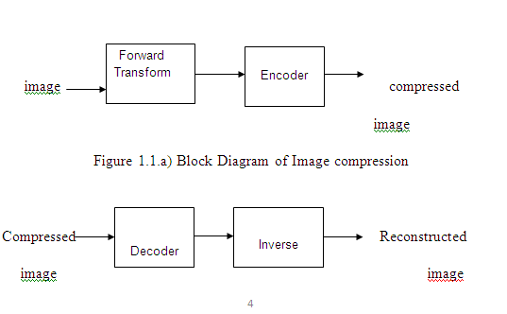
Fig:1.1b) Decompression Process for Image
Image Compression Types
There are two types’ image compression techniques.
1. Lossy Image compression
2. Lossless Image compression
Compression ratio:
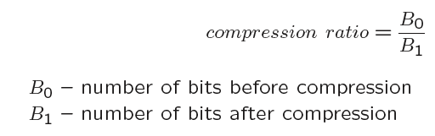
1. Lossy Image compression :
Lossy compression provides higher levels of data reduction but result in a less than perfect reproduction of the original image. It provides high compression ratio. lossy image compression is useful in applications such as broadcast television, videoconferencing, and facsimile transmission, in which a certain amount of error is an acceptable trade-off for increased compression performance. Originally, PGF has been designed to quickly and progressively decode lossy compressed aerial images. A lossy compression mode has been preferred, because in an application like a terrain explorer texture data (e.g., aerial orthophotos) is usually mid-mapped filtered and therefore lossy mapped onto the terrain surface. In addition, decoding lossy compressed images is usually faster than decoding lossless compressed images.
In the next test series we evaluate the lossy compression efficiency of PGF. One of the best competitors in this area is for sure JPEG 2000. Since JPEG 2000 has two different filters, we used the one with the better trade-off between compression efficiency and runtime. On our machine the 5/3 filter set has a better trade-off than the other. However, JPEG 2000 has in both cases a remarkable good compression efficiency for very high compression ratios but also a very poor encoding and decoding speed. The other competitor is JPEG. JPEG is one of the most popular image file formats.

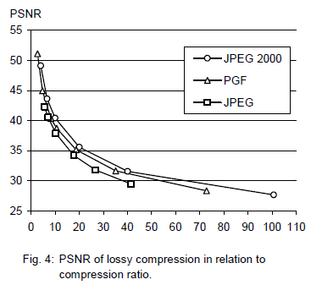
It is very fast and has a reasonably good compression efficiency for a wide range of compression ratios. The drawbacks of JPEG are the missing lossless compression and the often missing progressive decoding. Fig. 4 depicts the average rate-distortion behavior for the images in the Kodak test set when fixed (i.e., nonprogressive) lossy compression is used. The PSNR of PGF is on average 3% smaller than the PSNR of JPEG 2000, but 3% better than JPEG.
These results are also qualitative valid for our PGF test set and they are characteristic for aerial ortho-photos and natural images. Because of the design of PGF we already know that PGF does not reach the compression efficiency of JPEG 2000. However, we are interested in the trade-off between compression efficiency and runtime. To report this trade-off we show in Table 4 a comparison between JPEG 2000 and PGF and in Fig. 5 (on page 8) we show for the same test series as in Fig. 4 the corresponding average decoding times in relation to compression ratios.Table 4 contains for seven different compression ratios (mean values over the compression ratios of the eight images of the Kodak test set) the corresponding average encoding and decoding times in relation to the average PSNR values. In case of PGF the encoding time is always slightly longer than the corresponding decoding time. The reason for that is that the actual encoding phase (cf. Subsection 2.4.2) takes slightly longer than the corresponding decoding phase. For six of seven ratios the PSNR difference between JPEG 2000 and PGF is within 3% of the PSNR of JPEG 2000. Only in the first row is the difference larger (21%), but because a PSNR of 50 corresponds to an almost perfect image quality the large PSNR difference corresponds with an almost undiscoverable visual difference. The price they pay in JPEG 2000 for the 3% more PSNR is very high. The creation of a PGF is five to twenty times faster than the creation of a corresponding JPEG 2000 file, and the decoding of the created PGF is still five to ten times faster than the decoding of the JPEG 2000 file. This gain in speed is remarkable, especially in areas where time is more important than quality, maybe for instance in real-time computation.
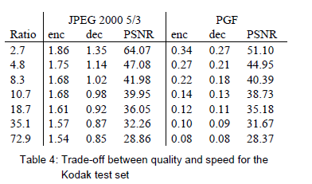
In Fig. 5 we see that the price we pay in PGF for the 3% more PSNR than JPEG is low: for small compression ratios (< 9) decoding in PGF takes two times longer than JPEG and for higher compression ratios (> 30) it takes only ten percent longer than JPEG. These test results are characteristic for both natural images and aerial ortho-photos. Again, in the third test series we only use the ‘Lena’ image. We run our lossy coder with six different quantization parameters and measure the PSNR in relation to the resulting compression ratios. The results (ratio: PSNR) are:
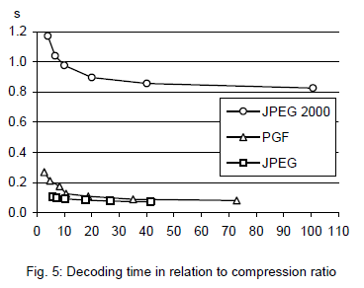

2.Lossless Image compression :
Lossless Image compression is the only acceptable amount of data reduction. It provides low compression ratio while compared to lossy. In Lossless Image compression techniques are composed of two relatively independent operations: (1) devising an alternative representation of the image in which its interpixel redundancies are reduced and (2) coding the representation to eliminate coding redundancies.
Lossless Image compression is useful in applications such as medical imaginary, business documents and satellite images.Table 2 summarizes the lossless compression efficiency and Table 3 the coding times of the PGF test set. For WinZip we only provide average runtime values, because of missing source code we have to use an interactive testing procedure with runtimes measured by hand. All other values are measured in batch mode.
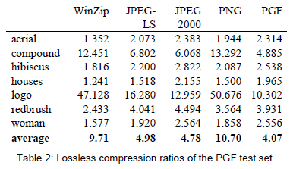
In Table 2 it can be seen that in almost all cases the best compression ratio is obtained by JPEG 2000, followed by PGF, JPEG-LS, and PNG. This result is different to the result in [SEA+00], where the best performance for a similar test set has been reported for JPEG-LS. PGF performs between 0.5% (woman) and 21.3% (logo) worse than JPEG 2000. On average it is almost 15% worse. The two exceptions to the general trend are the ‘compound’ and the ‘logo’ images. Both images contain for the most part black text on a white background. For this type of images, JPEG-LS and in particular WinZip and PNG provide much larger compression ratios. However, in average PNG performs the best, which is also reported in [SEA+00].
These results show, that as far as lossless compression is concerned, PGF performs reasonably well on natural and aerial images. In specific types of images such as ‘compound’ and ‘logo’ PGF is outperformed by far in PNG.
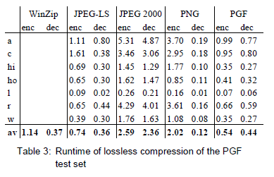
Table 3 shows the encoding (enc) and decoding (dec) times (measured in seconds) for the same algorithms and images as in Table 2. JPEG 2000 and PGF are both symmetric algorithms, while WinZip, JPEG-LS and in particular PNG are asymmetric with a clearly shorter decoding than encoding time. JPEG 2000, the slowest in encoding and decoding, takes more than four times longer than PGF. This speed gain is due to the simpler coding phase of PGF. JPEG-LS is slightly slower than PGF during encoding, but slightly faster in decoding images.
WinZip and PNG decode even more faster than JPEG-LS, but their encoding times are also worse. PGF seems to be the best compromise between encoding and decoding times.

Our PGF test set clearly shows that PGF in lossless mode is best suited for natural images and aerial ortho photos. PGF is the only algorithm that encodes the three Mega Byte large aerial ortho photo in less than second without a real loss of compression efficiency. For this particular image the efficiency loss is less than three percent compared to the best. These results should be underlined with our second test set, the Kodak test set.

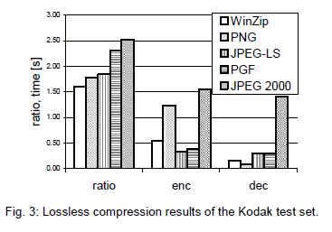
Fig. 3 shows the averages of the compression ratios (ratio), encoding (enc), and decoding (dec) times over all eight images. JPEG 2000 shows in this test set the best compression efficiency followed by PGF, JPEG-LS, PNG, and WinZip. In average PGF is eight percent worse than JPEG 2000. The fact that JPEG 2000 has a better lossless compression ratio than PGF does not surprise,
because JPEG 2000 is more quality driven than PGF.

However, it is remarkable that PGF is clearly better than JPEG-LS (+21%) and PNG (+23%) for natural images. JPEG-LS shows in the Kodak test set also a symmetric encoding and decoding time behaviour. It is encoding and decoding times are almost equal to PGF. Only PNG and WinZip can faster decode than PGF, but they also take longer than PGF to encode.
If both compression efficiency and runtime is important, then PGF is clearly the best of the tested algorithms for lossless compression of natural images and aerial ortho photos. In the third test we perform our lossless coder on the ‘Lena’ image.
To digitally process an image, it is first necessary to reduce the image to a series of numbers that can be manipulated by the computer. Each number representing the brightness value of the image at a particular location is called a picture element, or pixel. A typical digitized image may have 512 × 512 or roughly 250,000 pixels, although much larger images are becoming common. Once the image has been digitized, there are three basic operations that can be performed on it in the computer. For a point operation, a pixel value in the output image depends on a single pixel value in the input image. For local operations, several neighbouring pixels in the input image determine the value of an output image pixel. In a global operation, all of the input image pixels contribute to an output image pixel value.
Correspondingly, these combinations attempt to strike a winning tradeoff: be flexible and hence bring tolerance toward intraclass variation, while also being discriminative enough to be robust to background clutter and interclass similarity. An important feature of our contour-based recognition approach is that it affords us substantial flexibility to incorporate additional image information. Specifically, we extend the contour-based recognition method and propose a new hybrid recognition method which exploits shape tokens and SIFT features as recognition cues. Shape-tokens and SIFT features are largely orthogonal, where the former corresponds to shape boundaries and the latter to sparse salient image patches. Here, each learned combination can comprise features that are either 1) purely shape-tokens, 2) purely SIFT features, or 3) a mixture of shape-tokens and SIFT features. The number and types of features to be combined together are learned automatically from training images, and represent the more discriminative ones based on the training set. Consequently, by imparting these two degrees of variability (in both the number and the types of features) to a combination, we empower it with even greater flexibility and discriminative potential. A shorter version of this paper appeared in [9].

CLASSIFICATION OF IMAGES:

There are 3 types of images used in Digital Image Processing. They are

- Binary Image
- Gray Scale Image
- Colour Image

BINARY IMAGE:

A binary image is a digital image that has only two possible values for each pixel. Typically the two colors used for a binary image are black and white though any two colors can be used. The color used for the object(s) in the image is the foreground color while the rest of the image is the background color.
Binary images are also called bi-level or two-level. This means that each pixel is stored as a single bit (0 or 1).This name black and white, monochrome or monochromatic are often used for this concept, but may also designate any images that have only one sample per pixel, such as grayscale images
Binary images often arise in digital image processing as masks or as the result of certain operations such as segmentation, thresholding, and dithering. Some input/output devices, such as laser printers, fax machines, and bi-level computer displays, can only handle bi-level images
GRAY SCALE IMAGE
A grayscale Image is digital image is an image in which the value of each pixel is a single sample, that is, it carries only intensity information. Images of this sort, also known as black-and-white, are composed exclusively of shades of gray(0-255), varying from black(0) at the weakest intensity to white(255) at the strongest.
Grayscale images are distinct from one-bit black-and-white images, which in the context of computer imaging are images with only the two colors, black, and white (also called bi-level or binary images). Grayscale images have many shades of gray in between. Grayscale images are also called monochromatic, denoting the absence of any chromatic variation.
Grayscale images are often the result of measuring the intensity of light at each pixel in a single band of the electromagnetic spectrum (e.g. infrared, visible light, ultraviolet, etc.), and in such cases they are monochromatic proper when only a given frequency is captured. But also they can be synthesized from a full color image; see the section about converting to grayscale.
COLOUR IMAGE:
A (digital) color image is a digital image that includes color information for each pixel. Each pixel has a particular value which determines its appearing color. This value is qualified by three numbers giving the decomposition of the color in the three primary colors Red, Green and Blue. Any color visible to human eye can be represented this way. The decomposition of a color in the three primary colors is quantified by a number between 0 and 255. For example, white will be coded as R = 255, G = 255, B = 255; black will be known as (R,G,B) = (0,0,0); and say, bright pink will be : (255,0,255).
In other words, an image is an enormous two-dimensional array of color values, pixels, each of them coded on 3 bytes, representing the three primary colors. This allows the image to contain a total of 256x256x256 = 16.8 million different colors. This technique is also known as RGB encoding, and is specifically adapted to human vision

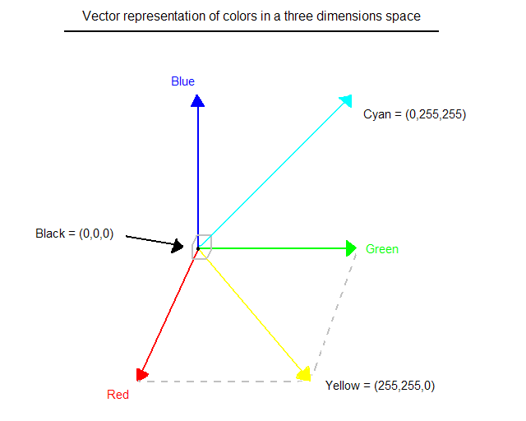
Fig.1 Hue Saturation Process of RGB SCALE Image
From the above figure, colors are coded on three bytes representing their decomposition on the three primary colors. It sounds obvious to a mathematician to immediately interpret colors as vectors in a three dimension space where each axis stands for one of the primary colors. Therefore we will benefit of most of the geometric mathematical concepts to deal with our colors, such as norms, scalar product, projection, rotation or distance.
SOFTWARE REQUIREMENTS
Python: Python Is An Object-Oriented, High Level Language, Interpreted, Dynamic And Multipurpose Programming Language.
Python Is Easy To Learn Yet Powerful And Versatile Scripting Language Which Makes It Attractive For Application Development.
Python's Syntax And Dynamic Typing With Its Interpreted Nature, Make It An Ideal Language For Scripting And Rapid Application Development In Many Areas.
Python Supports Multiple Programming Pattern, Including Object Oriented Programming, Imperative And Functional Programming Or Procedural Styles.
Python Is Not Intended To Work On Special Area Such As Web Programming. That Is Why It Is Known As Multipurpose Because It Can Be Used With Web, Enterprise, 3d Cad Etc.
We Don't Need To Use Data Types To Declare Variable Because It Is Dynamically Typed So We Can Write A=10 To Declare An Integer Value In A Variable.
Python Makes The Development And Debugging Fast Because There Is No Compilation Step Included In Python Development And Edit-Test-Debug Cycle Is Very Fast.
2. Python Features

1) Easy To Use:
Python Is Easy To Very Easy To Use And High Level Language. Thus It Is Programmer-Friendly Language.

2) Expressive Language:
Python Language Is More Expressive. The Sense Of Expressive Is The Code Is Easily Understandable.

3) Interpreted Language:
Python Is An Interpreted Language I.E. Interpreter Executes The Code Line By Line At A Time. This Makes Debugging Easy And Thus Suitable For Beginners.

4) Cross-Platform Language:
Python Can Run Equally On Different Platforms Such As Windows, Linux, Unix , Macintosh Etc. Thus, Python Is A Portable Language.

5) Free And Open Source:
Python Language Is Freely Available(Www.Python.Org).The Source-Code Is Also Available. Therefore It Is Open Source.

6) Object-Oriented Language:
Python Supports Object Oriented Language. Concept Of Classes And Objects Comes Into Existence.

7) Extensible:
It Implies That Other Languages Such As C/C++ Can Be Used To Compile The Code And Thus It Can Be Used Further In Your Python Code.

8) Large Standard Library:
Python Has A Large And Broad Library.

9) Gui Programming:
Graphical User Interfaces Can Be Developed Using Python.

10) Integrated:
It Can Be Easily Integrated With Languages Like C, C++, Java Etc.

3. Python History
- Python Laid Its Foundation In The Late 1980s.
- The Implementation Of Python Was Started In The December 1989 By Guido Van Rossum At Cwi In Netherland.
- Abc Programming Language Is Said To Be The Predecessor Of Python Language Which Was Capable Of Exception Handling And Interfacing With Amoeba Operating System.
- Python Is Influenced By Programming Languages Like:
  - Abc Language.
  - Modula-3

5. Python Applications
Python As A Whole Can Be Used In Any Sphere Of Development.
Let Us See What Are The Major Regions Where Python Proves To Be Handy.

1) Console Based Application
Python Can Be Used To Develop Console Based Applications. For Example: Ipython.

2) Audio Or Video Based Applications
Python Proves Handy In Multimedia Section. Some Of Real Applications Are: Timplayer, Cplay Etc.

3) 3d Cad Applications
Fandango Is A Real Application Which Provides Full Features Of Cad.

4) Web Applications
Python Can Also Be Used To Develop Web Based Application. Some Important Developments Are: Pythonwikiengines, Pocoo, Pythonblogsoftware Etc.

5) Enterprise Applications
Python Can Be Used To Create Applications Which Can Be Used Within An Enterprise Or An Organization. Some Real Time Applications Are: Openerp, Tryton, Picalo Etc.

6) Applications For Images
Using Python Several Application Can Be Developed For Image. Applications Developed Are: Vpython, Gogh, Imgseek Etc.
There Are Several Such Applications Which Can Be Developed Using Python

6. Python Example
Python Code Is Simple And Easy To Run. Here Is A Simple Python Code That Will Print "Welcome To Python".
A Simple Python Example Is Given Below.
- >>> A="Welcome To Python"
- >>> Print A
- Welcome To Python
- >>>
Explanation:
- Here We Are Using Idle To Write The Python Code. Detail Explanation To Run Code Is Given In Execute Python Section.
- A Variable Is Defined Named "A" Which Holds "Welcome To Python".
- "Print" Statement Is Used To Print The Content. Therefore "Print A" Statement Will Print The Content Of The Variable. Therefore, The Output "Welcome To Python" Is Produced.

Python 3.4 Example
In Python 3.4 Version, You Need To Add Parenthesis () In A String Code To Print It.
- >>> A=("Welcome To Python Example")
- >>> Print A
- Welcome To Python Example
- >>>

7. How To Execute Python

7. How To Execute Python
There Are Three Different Ways Of Working In Python:

1) Interactive Mode:
You Can Enter Python In The Command Prompt And Start Working With Python.
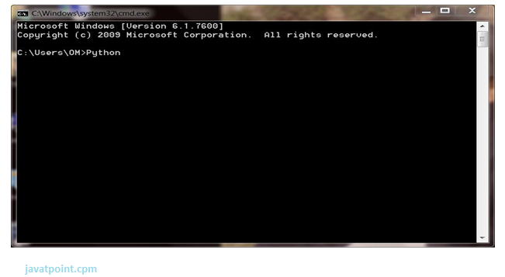
Press Enter Key And The Command Prompt Will Appear Like:
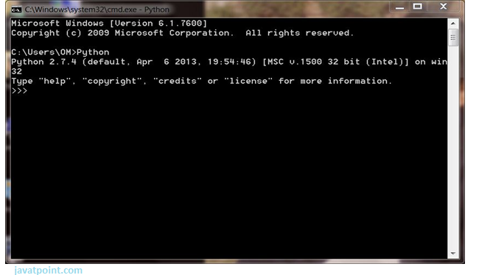
Now You Can Execute Your Python Commands.
Eg:
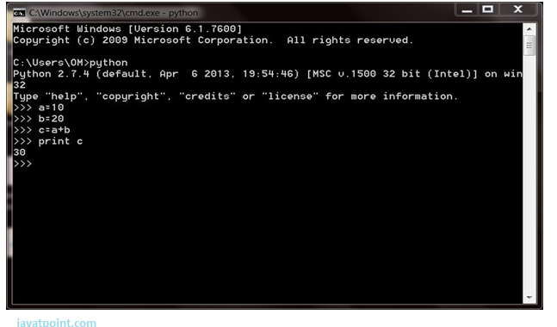

2) Script Mode:
Using Script Mode , You Can Write Your Python Code In A Separate File Using Any Editor Of Your Operating System.
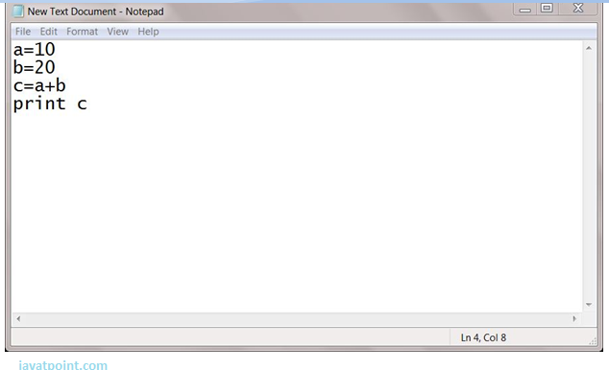
Save It By .Py Extension.
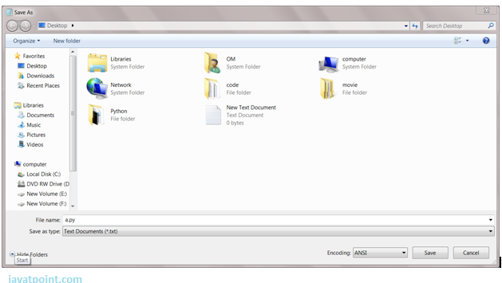
Now Open Command Prompt And Execute It By :
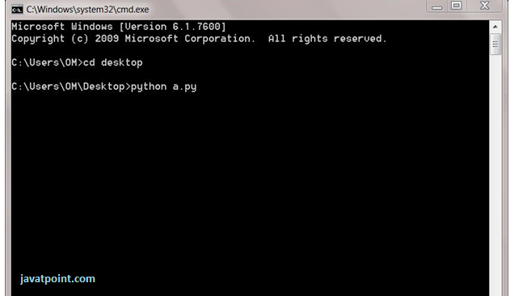
Note: Path In The Command Prompt Should Be Where You Have Saved Your File. In The Above Case File Should Be Saved At Desktop.

3) Using Ide: (Integrated Development Environment)
You Can Execute Your Python Code Using A Graphical User Interface (Gui).
All You Need To Do Is:
Click On Start Button -> All Programs -> Python -> Idle(Python Gui)
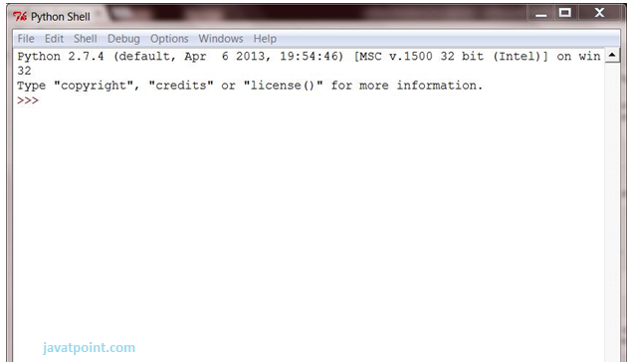
You Can Use Both Interactive As Well As Script Mode In Ide.
1) Using Interactive Mode:
Execute Your Python Code On The Python Prompt And It Will Display Result Simultaneously.
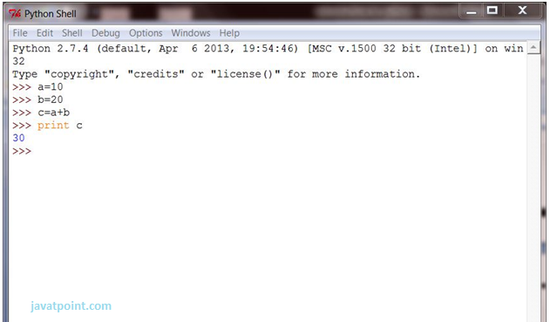
2) Using Script Mode:
I) Click On Start Button -> All Programs -> Python -> Idle(Python Gui)
Ii) Python Shell Will Be Opened. Now Click On File -> New Window.
A New Editor Will Be Opened . Write Your Python Code Here.
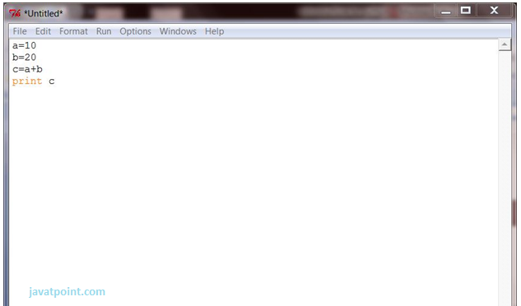
Click On File -> Save As
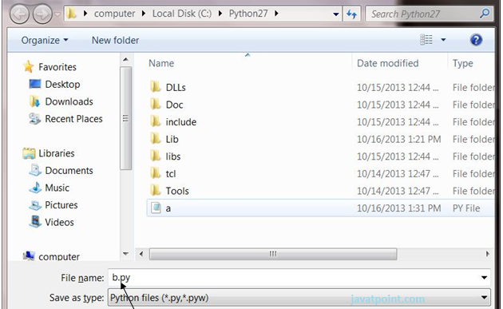
Run Then Code By Clicking On Run In The Menu Bar.
Run -> Run Module
Result Will Be Displayed On A New Python Shell As:
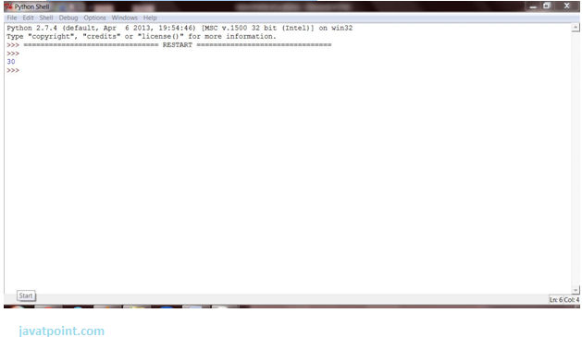

1) Using Interactive Mode:
Execute Your Python Code On The Python Prompt And It Will Display Result Simultaneously.
2) Using Script Mode:
I) Click On Start Button -> All Programs -> Python -> Idle(Python Gui)
Ii) Python Shell Will Be Opened. Now Click On File -> New Window.
A New Editor Will Be Opened . Write Your Python Code Here.
Run Then Code By Clicking On Run In The Menu Bar.
Run -> Run Module
Result Will Be Displayed On A New Python Shell As:
- Opencv:
Introduction To Computer Vision
Using Software To Parse The World’s Visual Content Is As Big Of A Revolution In Computing As Mobile Was 10 Years Ago, And Will Provide A Major Edge For Developers And Businesses To Build Amazing Products.
Computer Vision Is The Process Of Using Machines To Understand And Analyze Imagery (Both Photos And Videos). While These Types Of Algorithms Have Been Around In Various Forms Since The 1960’s, Recent Advances In Machine Learning, As Well As Leaps Forward In Data Storage, Computing Capabilities, And Cheap High-Quality Input Devices, Have Driven Major Improvements In How Well Our Software Can Explore This Kind Of Content.
What Is Computer Vision?
Computer Vision Is The Broad Parent Name For Any Computations Involving Visual Content – That Means Images, Videos, Icons, And Anything Else With Pixels Involved. But Within This Parent Idea, There Are A Few Specific Tasks That Are Core Building Blocks:
- In Object Classification, You Train A Model On A Dataset Of Specific Objects, And The Model Classifies New Objects As Belonging To One Or More Of Your Training Categories.
- For Object Identification, Your Model Will Recognize A Specific Instance Of An Object – For Example, Parsing Two Faces In An Image And Tagging One As Tom Cruise And One As Katie Holmes.
A Classical Application Of Computer Vision Is Handwriting Recognition For Digitizing Handwritten Content (We’ll Explore More Use Cases Below). Outside Of Just Recognition, Other Methods Of Analysis Include:
- Video Motion Analysis Uses Computer Vision To Estimate The Velocity Of Objects In A Video, Or The Camera Itself.
- In Image Segmentation, Algorithms Partition Images Into Multiple Sets Of Views.
- Scene Reconstruction Creates A 3d Model Of A Scene Inputted Through Images Or Video (Check Out Selva).
- In Image Restoration, Noise Such As Blurring Is Removed From Photos Using Machine Learning Based Filters.
Any Other Application That Involves Understanding Pixels Through Software Can Safely Be Labeled As Computer Vision.

How Computer Vision Works
One Of The Major Open Questions In Both Neuroscience And Machine Learning Is: How Exactly Do Our Offense and non-offenses Work, And How Can We Approximate That With Our Own Algorithms? The Reality Is That There Are Very Few Working And Comprehensive Theories Of Offense and non-offense Computation; So Despite The Fact That Neural Nets Are Supposed To “Mimic The Way The Offense and non-offense Works,” Nobody Is Quite Sure If That’s Actually True. Jeff Hawkins Has An Entire Book On This Topic Called On Intelligence.
The Same Paradox Holds True For Computer Vision – Since We’re Not Decided On How The Offense and non-offense And Eyes Process Images, It’s Difficult To Say How Well The Algorithms Used In Production Approximate Our Own Internal Mental Processes. For Example, Studies Have Shown That Some Functions That We Thought Happen In The Offense and non-offense Of Frogs Actually Take Place In The Eyes. We’re A Far Cry From Amphibians, But Similar Uncertainty Exists In Human Cognition.
Machines Interpret Images Very Simply: As A Series Of Pixels, Each With Their Own Set Of Color Values. Consider The Simplified Image Below, And How Grayscale Values Are Converted Into A Simple Array Of Numbers:
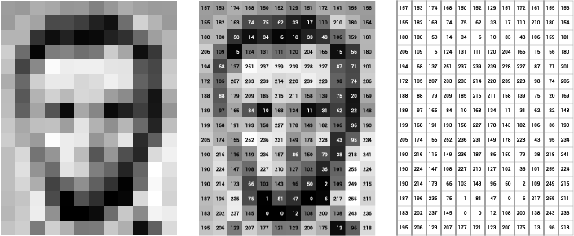
Source: Openframeworks
Think Of An Image As A Giant Grid Of Different Squares, Or Pixels (This Image Is A Very Simplified Version Of What Looks Like Either Abraham Lincoln Or A Dementor). Each Pixel In An Image Can Be Represented By A Number, Usually From 0 – 255. The Series Of Numbers On The Right Is What Software Sees When You Input An Image. For Our Image, There Are 12 Columns And 16 Rows, Which Means There Are 192 Input Values For This Image.
When We Start To Add In Color, Things Get More Complicated. Computers Usually Read Color As A Series Of 3 Values – Red, Green, And Blue (Rgb) – On That Same 0 – 255 Scale. Now, Each Pixel Actually Has 3 Values For The Computer To Store In Addition To Its Position. If We Were To Colorize President Lincoln (Or Harry Potter’s Worst Fear), That Would Lead To 12 X 16 X 3 Values, Or 576 Numbers.
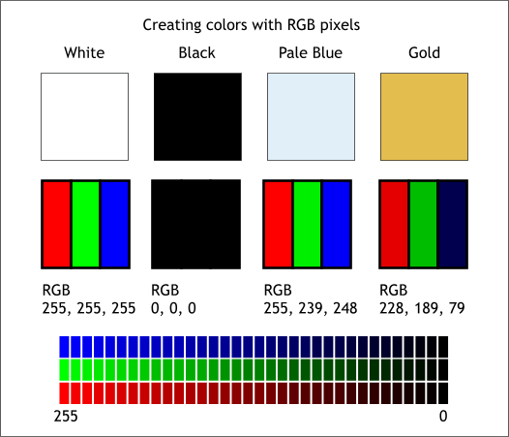
Source: Xaraxone
For Some Perspective On How Computationally Expensive This Is, Consider This Tree:
- Each Color Value Is Stored In 8 Bits.
- 8 Bits X 3 Colors Per Pixel = 24 Bits Per Pixel.
- A Normal Sized 1024 X 768 Image X 24 Bits Per Pixel = Almost 19m Bits, Or About 2.36 Megabytes.
That’s A Lot Of Memory To Require For One Image, And A Lot Of Pixels For An Algorithm To Iterate Over. But To Train A Model With Meaningful Accuracy – Especially When You’re Talking About Deep Learning – You’d Usually Need Tens Of Thousands Of Images, And The More The Merrier. Even If You Were To Use Transfer Learning To Use The Insights Of An Already Trained Model, You’d Still Need A Few Thousand Images To Train Yours On.
With The Sheer Amount Of Computing Power And Storage Required Just To Train Deep Learning Models For Computer Vision, It’s Not Hard To Understand Why Advances In Those Two Fields Have Driven Machine Learning Forward To Such A Degree.

Business Use Cases For Computer Vision
Computer Vision Is One Of The Areas In Machine Learning Where Core Concepts Are Already Being Integrated Into Major Products That We Use Every Day. Google Is Using Maps To Leverage Their Image Data And Identify Street Names, Businesses, And Office Buildings. Facebook Is Using Computer Vision To Identify People In Photos, And Do A Number Of Things With That Information.
But It’s Not Just Tech Companies That Are Leverage Machine Learning For Image Applications. Ford, The American Car Manufacturer That Has Been Around Literally Since The Early 1900’s, Is Investing Heavily In Autonomous Vehicles (Avs). Much Of The Underlying Technology In Avs Relies On Analyzing The Multiple Video Feeds Coming Into The Car And Using Computer Vision To Analyze And Pick A Path Of Action.
Another Major Area Where Computer Vision Can Help Is In The Medical Field. Much Of Diagnosis Is Image Processing, Like Reading X-Rays, Mri Scans, And Other Types Of Diagnostics. Google Has Been Working With Medical Research Teams To Explore How Deep Learning Can Help Medical Workflows, And Have Made Significant Progress In Terms Of Accuracy. To Paraphrase From Their Research Page:
“Collaborating Closely With Doctors And International Healthcare Systems, We Developed A State-Of-The-Art Computer Vision System For Reading Retinal Fundus Images For Diabetic Retinopathy And Determined Our Algorithm’s Performance Is On Par With U.S. Board-Certified Ophthalmologists. We’ve Recently Published Some Of Our Research In The Journal Of The American Medical Association And Summarized The Highlights In A Blog Post.”
But Aside From The Groundbreaking Stuff, It’s Getting Much Easier To Integrate Computer Vision Into Your Own Applications. A Number Of High-Quality Third Party Providers Like Clarifai Offer A Simple Api For Tagging And Understanding Images, While Kairos Provides Functionality Around Facial Recognition. We’ll Dive Into The Open-Source Packages Available For Use Below.
Computer Vision On Algorithmia
Algorithmia Makes It Easy To Deploy Computer Vision Applications As Scalable Microservices. Our Marketplace Has A Few Algorithms To Help Get The Job Done:
- Salnet Automatically Identifies The Most Important Parts Of An Image
- Nudity Detection Detects Nudity In Pictures
- Emotion Recognition Parses Emotions Exhibited In Images
- Deepstyle Transfers Next-Level Filters Onto Your Image
- Face Recognition…Recognizes Faces.
- Image Memorability Judges How Memorable An Image Is.
A Typical Workflow For Your Product Might Involve Passing Images From A Security Camera Into Emotion Recognition And Raising A Flag If Any Aggressive Emotions Are Exhibited, Or Using Nudity Detection To Block Inappropriate Profile Pictures On Your Web Application.
For A More Detailed Exploration Of How You Can Use The Algorithmia Platform To Implement Complex And Useful Computer Vision Tasks,

Computer Vision Resources

Packages And Frameworks
Opencv – “Opencv Was Designed For Computational Efficiency And With A Strong Focus On Real-Time Applications. Adopted All Around The World, Opencv Has More Than 47 Thousand People Of User Community And Estimated Number Of Downloads Exceeding 14 Million. Usage Ranges From Interactive Art, To Mines Inspection, Stitching Maps On The Web Or Through Advanced Robotics.”
Simplecv – “Simplecv Is An Open Source Framework For Building Computer Vision Applications. With It, You Get Access To Several High-Powered Computer Vision Libraries Such As Opencv – Without Having To First Learn About Bit Depths, File Formats, Color Spaces, Buffer Management, Eigenvalues, Or Matrix Versus Bitmap Storage.”
Mahotas – “Mahotas Is A Computer Vision And Image Processing Library For Python. It Includes Many Algorithms Implemented In C++ For Speed While Operating In Numpy Arrays And With A Very Clean Python Interface. Mahotas Currently Has Over 100 Functions For Image Processing And Computer Vision And It Keeps Growing.
- Num Py:
- Numpy, Which Stands For Numerical Python, Is A Library Consisting Of Multidimensional Array Objects And A Collection Of Routines For Processing Those Arrays. Using Numpy, Mathematical And Logical Operations On Arrays Can Be Performed. This Tutorial Explains The Basics Of Numpy Such As Its Architecture And Environment. It Also Discusses The Various Array Functions, Types Of Indexing, Etc. An Introduction To Matplotlib Is Also Provided. All This Is Explained With The Help Of Examples For Better Understanding.
- Audience
- This Tutorial Has Been Prepared For Those Who Want To Learn About The Basics And Various Functions Of Numpy. It Is Specifically Useful For Algorithm Developers. After Completing This Tutorial, You Will Find Yourself At A Moderate Level Of Expertise From Where You Can Take Yourself To Higher Levels Of Expertise.
- Prerequisites
- You Should Have A Basic Understanding Of Computer Programming Terminologies. A Basic Understanding Of Python And Any Of The Programming Languages Is A Plus.
- Numpy Is A Python Package. It Stands For 'Numerical Python'. It Is A Library Consisting Of Multidimensional Array Objects And A Collection Of Routines For Processing Of Array.
Numeric, The Ancestor Of Numpy, Was Developed By Jim Hugunin. Another Package Numarray Was Also Developed, Having Some Additional Functionalities. In 2005, Travis Oliphant Created Numpy Package By Incorporating The Features Of Numarray Into Numeric Package. There Are Many Contributors To This Open Source Project.

Operations Using Numpy
Using Numpy, A Developer Can Perform The Following Operations −
- Mathematical And Logical Operations On Arrays.
- Fourier Transforms And Routines For Shape Manipulation.
- Operations Related To Linear Algebra. Numpy Has In-Built Functions For Linear Algebra And Random Number Generation.

Numpy – A Replacement For Matlab
Numpy Is Often Used Along With Packages Like Scipy (Scientific Python) And Mat−Plotlib (Plotting Library). This Combination Is Widely Used As A Replacement For Matlab, A Popular Platform For Technical Computing. However, Python Alternative To Matlab Is Now Seen As A More Modern And Complete Programming Language.
The Most Important Object Defined In Numpy Is An N-Dimensional Array Type Called Ndarray. It Describes The Collection Of Items Of The Same Type. Items In The Collection Can Be Accessed Using A Zero-Based Index.
Every Item In An Ndarray Takes The Same Size Of Block In The Memory. Each Element In Ndarray Is An Object Of Data-Type Object (Called Dtype).
Any Item Extracted From Ndarray Object (By Slicing) Is Represented By A Python Object Of One Of Array Scalar Types. The Following Diagram Shows A Relationship Between Ndarray, Data Type Object (Dtype) And Array Scalar Type −
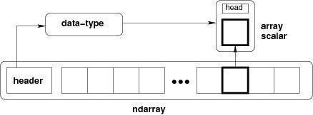
An Instance Of Ndarray Class Can Be Constructed By Different Array Creation Routines Described Later In The Tutorial. The Basic Ndarray Is Created Using An Array Function In Numpy As Follows −
Numpy.Array
It Creates An Ndarray From Any Object Exposing Array Interface, Or From Any Method That Returns An Array.
Imutils:
A Series Of Convenience Functions To Make Basic Image Processing Operations Such As Translation, Rotation, Resizing, Skeletonization, And Displaying Matplotlib Images Easier With Opencv And Python.
Transalation
Translation Is The Shifting Of An Image In Either The X Or Y Direction. To Translate An Image In Opencv You Need To Supply The (X, Y)-Shift, Denoted As (T_{x}, T_{y}) To Construct The Translation Matrix M:
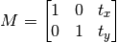
And From There, You Would Need To Apply The Cv2.Warpaffine Function.
Instead Of Manually Constructing The Translation Matrix M And Calling Cv2.Warpaffine , You Can Simply Make A Call To The Translate Function Of Imutils

Rotation
Rotating An Image In Opencv Is Accomplished By Making A Call Tocv2.Getrotationmatrix2d And Cv2.Warpaffine . Further Care Has To Be Taken To Supply The (X, Y)-Coordinate Of The Point The Image Is To Be Rotated About. These Calculation Calls Can Quickly Add Up And Make Your Code Bulky And Less Readable. The Rotate Function Inimutils Helps Resolve This Problem.

Resizing
Resizing An Image In Opencv Is Accomplished By Calling The Cv2.Resize Function. However, Special Care Needs To Be Taken To Ensure That The Aspect Ratio Is Maintained. Thisresize Function Of Imutils Maintains The Aspect Ratio And Provides The Keyword Arguments Width And Height So The Image Can Be Resized To The Intended Width/Height While (1) Maintaining Aspect Ratio And (2) Ensuring The Dimensions Of The Image Do Not Have To Be Explicitly Computed By The Developer.
Another Optional Keyword Argument, Inter , Can Be Used To Specify Interpolation Method As Well.

Skeletonization Is The Process Of Constructing The “Topological Skeleton” Of An Object In An Image, Where The Object Is Presumed To Be White On A Black Background. Opencv Does Not Provide A Function To Explicity Construct The Skeleton, But Does Provide The Morphological And Binary Functions To Do So.
For Convenience, The Skeletonize Function Of Imutils Can Be Used To Construct The Topological Skeleton Of The Image.
The First Argument, Size Is The Size Of The Structuring Element Kernel. An Optional Argument,Structuring , Can Be Used To Control The Structuring Element — It Defaults Tocv2.Morph_Rect , But Can Be Any Valid Structuring Element.
Displaying With Matplotlib
In The Python Bindings Of Opencv, Images Are Represented As Numpy Arrays In Bgr Order. This Works Fine When Using The Cv2.Imshow Function. However, If You Intend On Using Matplotlib, The Plt.Imshow Function Assumes The Image Is In Rgb Order. A Simple Call Tocv2.Cvtcolor Will Resolve This Problem, Or You Can Use The Opencv2matplotlib Convenience Function.

TensorFlow
the most famous deep learning library in the world is Google's TensorFlow. Google product uses machine learning in all of its products to improve the search engine, translation, image captioning or recommendations.
To give a concrete example, Google users can experience a faster and more refined the search with AI. If the user types a keyword a the search bar, Google provides a recommendation about what could be the next word.
Google wants to use machine learning to take advantage of their massive datasets to give users the best experience. Three different groups use machine learning:
- Researchers
- Data scientists
- Programmers.
They can all use the same toolset to collaborate with each other and improve their efficiency.
Google does not just have any data; they have the world's most massive computer, so TensorFlow was built to scale. TensorFlow is a library developed by the Google Offense and non-offense Team to accelerate machine learning and deep neural network research.
It was built to run on multiple CPUs or GPUs and even mobile operating systems, and it has several wrappers in several languages like Python, C++ or Java.
In this tutorial, you will learn
TensorFlow Architecture
Tensor flow architecture works in three parts:
Pre processing the datA
Build the model
Train and estimate the model

It is called Tensor flow because it takes input as a multi-dimensional array, also known as tensors. You can construct a sort of flowchart of operations (called a Graph) that you want to perform on that input. The input goes in at one end, and then it flows through this system of multiple operations and comes out the other end as output.
This is why it is called TensorFlow because the tensor goes in it flows through a list of operations, and then it comes out the other side.
Where can Tensor flow run?
TensorFlow can hardware, and software requirements can be classified into
Development Phase: This is when you train the mode. Training is usually done on your Desktop or laptop.
Run Phase or Inference Phase: Once training is done Tensorflow can be run on many different platforms. You can run it on
Desktop running Windows, macOS or Linux
Cloud as a web service
Mobile devices like iOS and Android
You can train it on multiple machines then you can run it on a different machine, once you have the trained model.
The model can be trained and used on GPUs as well as CPUs. GPUs were initially designed for video games. In late 2010, Stanford researchers found that GPU was also very good at matrix operations and algebra so that it makes them very fast for doing these kinds of calculations. Deep learning relies on a lot of matrix multiplication. TensorFlow is very fast at computing the matrix multiplication because it is written in C++. Although it is implemented in C++, TensorFlow can be accessed and controlled by other languages mainly, Python.
Finally, a significant feature of Tensor Flow is the Tensor Board. The Tensor Board enables to monitor graphically and visually what TensorFlow is doing.
List of Prominent Algorithms supported by TensorFlow
- Linear regression: tf. estimator .Linear Regressor
- Classification :tf. Estimator .Linear Classifier
- Deep learning classification: tf. estimator. DNN Classifier
- Booster tree regression: tf.estimator.BoostedTreesRegressor
- Boosted tree classification: tf.estimator.BoostedTreesClassifier

- Python idle
- Anaconda navigator
- opencv

1.2 HARDWARE REQUIREMENTS
The most common set of requirements defined by any operating system or software application is the physical computer resources, also known as hardware, A hardware requirements list is often accompanied by a hardware compatibility list (HCL), especially in case of operating systems. An HCL lists tested, compatible, and sometimes incompatible hardware devices for a particular operating system or application. The following sub-sections discuss the various aspects of hardware requirements.
Architecture – All computer operating systems are designed for a particular computer architecture. Most software applications are limited to particular operating systems running on particular architectures. Although architecture-independent operating systems and applications exist, most need to be recompiled to run on a new architecture. See also a list of common operating systems and their supporting architectures.
Processing power – The power of the central processing unit (CPU) is a fundamental system requirement for any software. Most software running on x86 architecture define processing power as the model and the clock speed of the CPU. Many other features of a CPU that influence its speed and power, like bus speed, cache, and MIPS are often ignored. This definition of power is often erroneous, as AMD Athlon and Intel Pentium CPUs at similar clock speed often have different throughput speeds. Intel Pentium CPUs have enjoyed a considerable degree of popularity, and are often mentioned in this category.
Memory – All software, when run, resides in the random access memory (RAM) of a computer. Memory requirements are defined after considering demands of the application, operating system, supporting software and files, and other running processes. Optimal performance of other unrelated software running on a multi-tasking computer system is also considered when defining this requirement.
Secondary storage – Hard-disk requirements vary, depending on the size of software installation, temporary files created and maintained while installing or running the software, and possible use of swap space (if RAM is insufficient).
Display adapter – Software requiring a better than average computer graphics display, like graphics editors and high-end games, often define high-end display adapters in the system requirements.
Peripherals – Some software applications need to make extensive and/or special use of some peripherals, demanding the higher performance or functionality of such peripherals. Such peripherals include CD-ROM drives, keyboards, pointing devices, network devices, etc.
1)Operating System : Windows Only
2)Processor : i5 and above
3)Ram : 4gb and above
4)Hard Disk : 50 GB

LITERATURE REVIEW:

TITLE:Fully Automatic Knee Bone Detection and Segmentation on Three-Dimensional MRI

Abstract:
In the medical sector, three-dimensional (3D) images are commonly used like computed tomography (CT) and magnetic resonance imaging (MRI). The 3D MRI is a non-invasive method of studying the soft-tissue structures in a knee joint for osteoarthritis studies. It can greatly improve the accuracy of segmenting structures such as cartilage, bone marrow lesion, and meniscus by identifying the bone structure first. U-net is a convolutional neural network that was originally designed to segment the biological images with limited training data. The input of the original U-net is a single 2D image and the output is a binary 2D image. In this study, we modified the U-net model to identify the knee bone structures using 3D MRI, which is a sequence of 2D slices. A fully automatic model has been proposed to detect and segment knee bones. The proposed model was trained, tested, and validated using 99 knee MRI cases where each case consists of 160 2D slices for a single knee scan. To evaluate the model's performance, the similarity, dice coefficient (DICE), and area error metrics were calculated. Separate models were trained using different knee bone components including tibia, femur, patella, as well as a combined model for segmenting all the knee bones. Using the whole MRI sequence (160 slices), the method was able to detect the beginning and ending bone slices first, and then segment the bone structures for all the slices in between. On the testing set, the detection model accomplished 98.79% accuracy and the segmentation model achieved DICE 96.94% and similarity 93.98%. The proposed method outperforms several state-of-the-art methods, i.e., it outperforms U-net by 3.68%, SegNet by 14.45%, and FCN-8 by 2.34%, in terms of DICE score using the same dataset.
Keywords: 3D MRI; U-net; convolutional neural networks; fully automatic bone detection and bone segmentation; knee osteoarthritis.
AUTHORS:
Rania Almajalid 1 2, Ming Zhang 3 4, Juan Shan 1

The optimisation of deep neural networks for segmenting multiple knee joint tissues from MRIs

Abstract:
Automated semantic segmentation of multiple knee joint tissues is desirable to allow faster and more reliable analysis of large datasets and to enable further downstream processing e.g. automated diagnosis. In this work, we evaluate the use of conditional Generative Adversarial Networks (cGANs) as a robust and potentially improved method for semantic segmentation compared to other extensively used convolutional neural network, such as the U-Net. As cGANs have not yet been widely explored for semantic medical image segmentation, we analysed the effect of training with different objective functions and discriminator receptive field sizes on the segmentation performance of the cGAN. Additionally, we evaluated the possibility of using transfer learning to improve the segmentation accuracy. The networks were trained on i) the SKI10 dataset which comes from the MICCAI grand challenge "Segmentation of Knee Images 2010″, ii) the OAI ZIB dataset containing femoral and tibial bone and cartilage segmentations of the Osteoarthritis Initiative cohort and iii) a small locally acquired dataset (Advanced MRI of Osteoarthritis (AMROA) study) consisting of 3D fat-saturated spoiled gradient recalled-echo knee MRIs with manual segmentations of the femoral, tibial and patellar bone and cartilage, as well as the cruciate ligaments and selected peri-articular muscles. The Sørensen-Dice Similarity Coefficient (DSC), volumetric overlap error (VOE) and average surface distance (ASD) were calculated for segmentation performance evaluation. DSC ≥ 0.95 were achieved for all segmented bone structures, DSC ≥ 0.83 for cartilage and muscle tissues and DSC of ≈0.66 were achieved for cruciate ligament segmentations with both cGAN and U-Net on the in-house AMROA dataset. Reducing the receptive field size of the cGAN discriminator network improved the networks segmentation performance and resulted in segmentation accuracies equivalent to those of the U-Net. Pretraining not only increased segmentation accuracy of a few knee joint tissues of the fine-tuned dataset, but also increased the network's capacity to preserve segmentation capabilities for the pretrained dataset. cGAN machine learning can generate automated semantic maps of multiple tissues within the knee joint which could increase the accuracy and efficiency for evaluating joint health.
Keywords: Convolutional neural network (CNN); Generative adversarial network (GAN); Image segmentation; Magnetic resonance imaging (MRI); Musculoskeletal.

AUTHORS:
Dimitri A Kessler 1, James W MacKay 2, Victoria A Crowe 3, Frances M D Henson 4, Martin J Graves 3, Fiona J Gilbert 5, Joshua D Kaggie 6

Automated knee cartilage segmentation for heterogeneous clinical MRI using generative adversarial networks with transfer learning

Abstract:
This study aimed to build a deep learning model to automatically segment heterogeneous clinical MRI scans by optimizing a pre-trained model built from a homogeneous research dataset with transfer learning.
Keywords: Generative adversarial networks; automated segmentation; clinical knee MRI; deep learning; transfer learning.
AUTHORS:
Mingrui Yang 1 2, Ceylan Colak 3, Kishore K Chundru 3, Sibaji Gaj 1 2, Andreas Nanavati 1 2, Morgan H Jones 4, Carl S Winalski 1 2 3, Naveen Subhas 2 3, Xiaojuan Li 1 2 3

Automated cartilage and meniscus segmentation of knee MRI with conditional generative adversarial networks

Abstract:
Fully automatic tissue segmentation is an essential step to translate quantitative MRI techniques to clinical setting. The goal of this study was to develop a novel approach based on the generative adversarial networks for fully automatic segmentation of knee cartilage and meniscus.Defining proper loss function for semantic segmentation to enforce the learning of multiscale spatial constraints in an end-to-end training process is an open problem. In this work, we have used the conditional generative adversarial networks to improve segmentation performance of convolutional neural network, such as UNet alone by overcoming the problems caused by pixel-wise mapping based objective functions, and to capture cartilage features during the training of the network. Furthermore, the Dice coefficient and cross entropy losses were incorporated to the loss functions to improve the model performance. The model was trained and tested on 176, 3D DESS (double-echo steady-state) knee images from the Osteoarthritis Initiative data set.
Keywords: automated segmentation; deep learning; generative adversarial networks; knee cartilage and meniscus.
AUTHORS:
Sibaji Gaj 1, Mingrui Yang 1, Kunio Nakamura 1, Xiaojuan Li 1
Fully Automatic Knee Bone Detection and Segmentation onThree-Dimensional MRI

ABSTRACT:
stract:In the medical sector, three-dimensional (3D) images are commonly used like computedtomography (CT) and magnetic resonance imaging (MRI). The 3D MRI is a non-invasive method ofstudying the soft-tissue structures in a knee joint for osteoarthritis studies. It can greatly improve theaccuracy of segmenting structures such as cartilage, bone marrow lesion, and meniscus by identifyingthe bone structure ﬁrst. U-net is a convolutional neural network that was originally designed tosegment the biological images with limited training data. The input of the original U-net is a single2D image and the output is a binary 2D image. In this study, we modiﬁed the U-net model to identifythe knee bone structures using 3D MRI, which is a sequence of 2D slices. A fully automatic modelhas been proposed to detect and segment knee bones. The proposed model was trained, tested, andvalidated using 99 knee MRI cases where each case consists of 160 2D slices for a single knee scan.To evaluate the model’s performance, the similarity, dice coefﬁcient (DICE), and area error metricswere calculated. Separate models were trained using different knee bone components including tibia,femur, patella, as well as a combined model for segmenting all the knee bones. Using the whole MRIsequence (160 slices), the method was able to detect the beginning and ending bone slices ﬁrst, andthen segment the bone structures for all the slices in between. On the testing set, the detection modelaccomplished 98.79% accuracy and the segmentation model achieved DICE 96.94% and similarity93.98%. The proposed method outperforms several state-of-the-art methods, i.e., it outperforms U-netby 3.68%, SegNet by 14.45%, and FCN-8 by 2.34%, in terms of DICE score using the same dataset.
KEYWORDS:
Keywords:knee osteoarthritis; fully automatic bone detection and bone segmentation; 3D MRI;convolutional neural networks; U-net
AUTORS:
Rania Almajalid 1,2 , Ming Zhang 3,4,* and Juan Shan 1,*1Department of Computer Science, Seidenberg School of CSIS, Pace University, New York, NY 10038, USA;ra56319p@pace.edu2College of Computing and Informatics, Saudi Electronic University, Riyadh 11673, Saudi Arabia3Department of Computer Science & Networking, Wentworth Institute of Technology, Boston, MA 02115, USA4Division of Rheumatology, Tufts Medical Center, Boston, MA 02111, USA*Correspondence: zhangm1@wit.edu (M.Z.); jshan@pace.edu (J.S.)

Knee Osteoarthritis Detection Using Deep Feature Based on Convolutional Neural Network
Abstract:
Various diseases have recently wreaked influence on people's way of life. Several bone illnesses significantly influence the quality of life, including Knee Osteoarthritis. When the cartilage in the knee joint between the femur and tibia wears down, it causes Knee Osteoarthritis, which results in significant j oint pain, joint movement restrictions, gait abnormalities, and even effusion. This study presents a method based on deep features. We employed Convolutional Neural Network to extract deep features from Knee Osteoarthritis images. Then, the extracted features are fed to different machine learning classifiers, namely Support Vector Machine, K-Nearest Neighbour, and Naive Bayes. The classification of this work has been performed to differentiate between healthy and unhealthy Knee Osteoarthritis images. The experimental result uses different evaluation matrices to test this work by obtaining 90.01 % of accuracy, 90% recall, and 87.8% specificity. The obtained results showed that the K-Nearest Neighbour based deep features achieved better classification accuracy compared to Support Vector Machine and Naive Bayes.

KEYWORDS:
Knee,Support vector machines,Image segmentation,Machine learning,Feature extraction,Convolutional neuralnetworks,Osteoarthritis
AUTHORS:
Dilovan Asaad Zebari
Dept of Computer Science, College of Science, Nawroz University, Duhok, Kurdistan Region, Iraq

Knee Osteoarthritis Detection Using an Improved CenterNet With Pixel-Wise Voting Scheme

ABSTRACT
To detect knee disease, radiologists have been utilizing multi-view images such as computer tomography (CT) scans, MRIs, and X-rays. The cheapest method is X-ray to attain the images that is used widely. There exist various image processing techniques to detect knee disease at the initial stages; however, there is still room for improved accuracy and precision of the existing algorithms. Furthermore, in machine learning-based techniques, hand-crafted feature extraction mechanism is a tedious task. Therefore, in this paper, we suggest a technique based on customized CenterNet with a pixel-wise voting scheme to extract the features automatically. Our model uses the most representative features due to the best localization results and a weighted pixel-wise voting scheme which takes input from a predicted bounding box using modified CenterNet. It gives a more accurate bounding box based on the voting score from each pixel inside the former box. Moreover, we employed the distillation knowledge concept to make our model simple without increasing its computational cost, and transfer knowledge from a complex network to a simple network. Therefore, our proposed model detects the KOA in knee images precisely and determines its severity level according to the KL grading system such as Grade-I, Grade-II, Grade-III, and Grade-IV. Our proposed model is a robust and improved architecture based on CenterNet utilizing a simple DenseNet-201 as a base network for feature extraction. Due to the dense blocks employed in a base network, most representative features are extracted from the knee samples. We employed two benchmarks i.e. Mendeley VI for the training, and testing, and the OAI dataset for cross-validation. We evaluated the performance of the proposed technique using various experiments and it is estimated that our proposed model outperforms the existing techniques with an accuracy of 99.14% over testing and 98.97% over cross-validation.

AUTHORS:
SULIMAN ALADHADH 1 AND RABBIA MAHUM 2 1Department of Information Technology, College of Computer, Qassim University, Buraydah 52571, Saudi Arabia 2Department of Computer Science, UET Taxila, Taxila 47050, Pakistan Corresponding author: Rabbia Mahum (rabbia.mahum@uettaxila.edu.pk) This work was supported by the Deanship of Scientific Research, Qassim University.
KEYWORD:
Machine learning, detection performance, HCI, classification, deep learning, multi-scale features.

A Knee X-ray Database for Osteoporosis Detection

Abstract:
Osteoporosis is the leading pathological disorder of bones after arthritis affecting millions of people worldwide. The diagnosis of osteoporosis is done by Dual Energy X-ray Absorptiometry (DXA), although it gives good results but its cost is very high and is not readily available and the treatment cost of osteoporosis is also very high so there is a need for some cost-effective and easily available detection system. The researchers are in continuous search of finding new ways of detecting osteoporosis at early stages with less cost and in less time. The researchers mostly use their build in datasets instead of publically available datasets that make the study limited to particular regions and particular populations. To make a detection system, that is accepted worldwide and used as an alternative pre-screening tool there is a need to make the research data-centric which implies researchers from different areas of research and different countries should work on some particular datasets and find a common solution. Inspired by this scenario, we have presented the database for the detection of osteoporosis in this article. The database consists of clinical factors like age, gender, menopause age, other diseases like diabetes, thryroidism, fracture history, lifestyle factors, etc responsible for osteoporosis with the T-score values obtained from the Quantitative Ultrasound System and Knee X-ray for each participant. The main objective of this dataset is to make the research of finding the cost-effective, timely, and accurate osteoporotic detection system data-centric.

Keywords:
Osteoporosis,Pathology,Costs,Ultrasonic imaging,Databases,Tools,Bones

AUTHORS:
Insha Majeed Wani School of Computer Science and Engineering, Shri Mata Vaishno Devi University, Katra, J&K

Knee Osteoarthritis Detection and Severity Classification Using Residual Neural Networks on Preprocessed X-ray Images
ABSTRACT:
One of the most common and challenging medical conditions to deal with in old-aged people is the occurrence of knee osteoarthritis (KOA). Manual diagnosis of this disease involves observing X-ray images of the knee area and classifying it under five grades using the Kellgren–Lawrence (KL) system. This requires the physician’s expertise, suitable experience, and a lot of time, and even after that the diagnosis can be prone to errors. Therefore, researchers in the ML/DL domain have employed the capabilities of deep neural network (DNN) models to identify and classify KOA images in an automated, faster, and accurate manner. To this end, we propose the application of six pretrained DNN models, namely, VGG16, VGG19, ResNet101, MobileNetV2, InceptionResNetV2, and DenseNet121 for KOA diagnosis using images obtained from the Osteoarthritis Initiative (OAI) dataset. More specifically, we perform two types of classification, namely, a binary classification, which detects the presence or absence of KOA and secondly, classifying the severity of KOA in a three-class classification. For a comparative analysis, we experiment on three datasets (Dataset I, Dataset II, and Dataset III) with five, two, and three classes of KOA images, respectively. We achieved maximum classification accuracies of 69%, 83%, and 89%, respectively, with the ResNet101 DNN model. Our results show an improved performance from the existing work in the literature

Keywords: knee osteoarthritis, residual neural networks, X-ray images, severity classification

AUTHORS:
Abdul Sami Mohammed, Software, Investigation, Data curation, Writing –original draft,1 Ahmed Abul Hasanaath, Methodology, Software, Validation, Writing – original draft,2 Ghazanfar Latif, Conceptualization, Methodology, Formal analysis, Funding acquisition,2 and Abul Bashar, Resources, Writing – review & editing, Project administration, Funding acquisition1.

An Automatic Knee Osteoarthritis Diagnosis Method Based on Deep Learning: Data from the Osteoarthritis Initiative.

Abstract:
Osteoarthritis (OA) is the most common form of arthritis. According to the evidence presented on both sides of the knee bones, radiologists assess the severity of OA based on the Kellgren–Lawrence (KL) grading system. Recently, computer-aided methods are proposed to improve the efficiency of OA diagnosis. However, the human interventions required by previous semiautomatic segmentation methods limit the application on large-scale datasets. Moreover, well-known CNN architectures applied to the OA severity assessment do not explore the relations between different local regions. In this work, by integrating the object detection model, YOLO, with the visual transformer into the diagnosis procedure, we reduce human intervention and provide an end-to-end approach to automatic osteoarthritis diagnosis. Our approach correctly segments 95.57% of data at the expense of training on 200 annotated images on a large dataset that contains more than 4500 samples. Furthermore, our classification result improves the accuracy by 2.5% compared to the traditional CNN architectures.

KEYWORDS:Osteoarthritis,segmentation,CNN.

AUTHORS:

Yifan Wang,1Xianan Wang,1Tianning Gao,1Le Du,2and Wei Liu2
Show more

EXISTING SYSTEM:
- K means clustering
- KNN classifier

DISADVANDAGE:
- Difficult to get accurate results
- Not applicable for multiple images for lesion segmented in a short time
- Poor discriminatory power and less classification accuracy k-means clustering

PROPOSSED METHOD:
- PREPROSSES
- FEATUER EXTRACTION
- CNN
ADVANDAGES:
- high accuracy in bone detection and segmentation tasks
- speeding up the process of bone detection and segmentation in knee imaging.
- This consistency is crucial for accurate diagnosis and treatment monitoring.

BLOCK DIAGRAM:
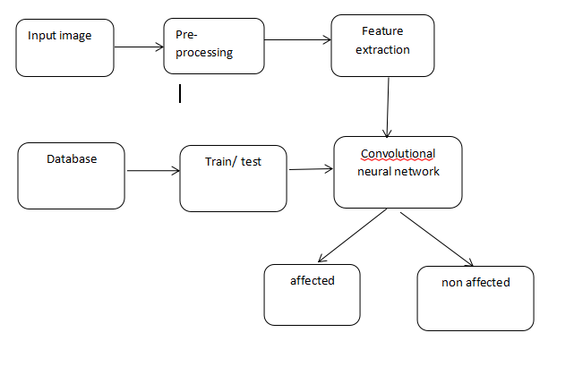

APPLICATIONS:
- MEDICAL APPLICATION
- Rehabilitation and Physical Therapy
IMPLEMENTATION MODULE:
Image acquisition: image acquisition is an action of retrieving image from an external source for further processing. It's always the foundation step in the workflow since no process is available before obtaining an image.
Pre-process: pre-processing is an improvement of the image data that suppresses unwilling distortions or enhances some image features important for further processing, although geometric transformations of images (e.g. rotation, scaling, translation) are classified among pre-processing methods.
Feature extraction: Feature extraction helps to reduce the amount of redundant data from the data set. In the end, the reduction of the data helps to build the model with less machine effort and also increases the speed of learning and generalization steps in the machine learning process.
Train and test splitting:
Training consists in learning a relation between data and attributes from a fraction of the training dataset, and testing consists in testing predictions of this relation on another part of the dataset (since you know the prediction, you can compare the output of the relation and the real attributes).
ALGORITHM AND EXPLANATION:
ALGORITHM This Deep Training algorithm, known as a Convolutional Neural (CNN), can take in an image, assign importance (learnable weights and biases) to diverse elements there in picture, and make a distinction fact from opinion. When especially in comparison to other classification algorithms, the amount of pre-processing required by a ConvNet is significantly lower. Convolutional neural networks have the ability to learn these filters/characteristics if they are given enough training. Architecture of CNN is similar to that of human brain connectivity patterns and was inspired by visual cortex organisation. The Receptive Field is the area of the visual field in which individual neurons respond to stimuli. All of the visible space is filled by a smattering of these fields. Enter a colour image from the source Quality of Grain for Food. The first step is to get the image of rice grains. Using preprocessing, improve the image quality (RGB to Gray, Noise Removal etc). Image Segmentation can then be used to identify ROIs.Take features and feed them into the model as input. Using ML Algorithms, identify and classify rice grain samples based on these features. Convolutional Neural Networks: As in any other neural network, the input of a CNN, in this case an image, is passed through a series of filters in order to obtain a labelled output that can then be classified. The specificity of a CNN lies in its filtering layers, which include at least one convolution layer. These allow it to process more complex pictures than a regular neural network. Whereas the latter is well adapted for simple, well-centred images such as hand-written digits, the use of CNNs in image analysis ranges from Facebook’s automatic tagging algorithms, to object classification and detection, in particular in the field of radiology.
There are Four types of layers in Convolutional Neural Networks:
- Convolutional Layer: In a typical neural network each input neuron is connected to the next hidden layer. In CNN, only a small region of the input layer neurons connect to the neuron hidden layer.
- Pooling Layer: The pooling layer is used to reduce the dimensionality of the feature map. There will be multiple activation pooling layers inside the hidden layer of the CNN.
- Flatten: Flattening is converting the data into a 1-dimensional array for inputting it to the next layer. We flatten the output of the convolutional layers to create a single long feature vector.
4) Fully-Connected layer:Fully Connected Layers form the last few layers in the network. The input to the fully connected layer is the output from the final Pooling or Convolutional Layer, which is flattened and then fed into the fully connected layer.
CONCLUSION:
The study successfully demonstrates that the combination of gait data and radio graphic images, analyzed through advanced machine learning frameworks, provides a powerful tool for the automatic classification of knee osteoarthritis severity. This approach has the potential to improve diagnostic accuracy, optimize treatment strategies, and ultimately enhance patient outcomes in clinical settings.
REFERENCES:
1.Losina, E.; Daigle, M.E.; Suter, L.; Hunter, D.; Solomon, D.; Walensky, R.; Jordan, J.; Burbine, S.A.; Paltiel, A.D.; Katz, J.N.Disease-modifying drugs for knee osteoarthritis: can they be cost-effective? Osteoarthr. Cartil. 2013, 21, 655–667. [CrossRef][PubMed]
2. Felson, D.T. Osteoarthritis as a disease of mechanics. Osteoarthr. Cartil. 2013, 21, 10–15. [CrossRef]
3. Felson, D.T.; Lawrence, R.C.; Dieppe, P.A.; Hirsch, R.; Helmick, C.G.; Jordan, J.M.; Kington, R.S.; Lane, N.E.; Nevitt, M.C.;Zhang, Y.; et al. Osteoarthritis: new insights. Part 1: The disease and its risk factors. Ann. Intern. Med. 2000, 133, 635–646.[CrossRef] [PubMed]
4. National Institutes of Health. Osteoarthritis Initiative Releases First Data; News Releases, US Department of Health & HumanServices: Bethesda, MD, USA, 2006.
5. Yelin, E.; Weinstein, S.; King, T. The Burden of Musculoskeletal Diseases in the United States; Seminars in Arthritis and Rheumatism;Elsevier: Amsterdam, The Netherlands, 2016; Volume 46, pp. 259–260.
6. Losina, E.; Paltiel, A.D.; Weinstein, A.M.; Yelin, E.; Hunter, D.J.; Chen, S.P.; Klara, K.; Suter, L.G.; Solomon, D.H.;Burbine, S.A.; et al. Lifetime medical costs of knee osteoarthritis management in the United States: Impact of extendingindications for total knee arthroplasty. Arthritis Care Res. 2015, 67, 203–215. [CrossRef]
7. Jevsevar, D.S. Treatment of osteoarthritis of the knee: evidence-based guideline. JAAOS-J. Am. Acad. Orthop. Surg. 2013,21, 571–576.
8. Guccione, A.A.; Felson, D.T.; Anderson, J.J.; Anthony, J.M.; Zhang, Y.; Wilson, P.W.; Kelly-Hayes, M.; Wolf, P.A.; Kreger, B.E.;Kannel, W.B. The effects of specific medical conditions on the functional limitations of elders in the Framingham Study. Am. J.Public Health 1994, 84, 351–358. [CrossRef]
9. Heidari, B. Knee osteoarthritis prevalence, risk factors, pathogenesis and features: Part I. Casp. J. Intern. Med. 2011, 2, 205.
10. Bhatia, D.; Bejarano, T.; Novo, M. Current interventions in the management of knee osteoarthritis. J. Pharm. Bioallied Sci. 2013,5, 30. [CrossRef]

